Analysis of Adverse Drug Reaction Patterns Using FDA FAERS Data

Project Overview
Pharmacovigilance plays a critical role in ensuring drug safety by monitoring, assessing, and preventing adverse drug reactions after a product is released into the market. The U.S. Food and Drug Administration’s Adverse Event Reporting System (FAERS) is a widely used public database that collects spontaneous reports of adverse drug events submitted by healthcare professionals, consumers, and pharmaceutical manufacturers.
This mini project focuses on analyzing FAERS data to understand adverse drug event reporting patterns using data analytics and visualization techniques. The project follows an end-to-end analytical workflow, beginning with data cleaning and transformation in Microsoft Excel, followed by data modeling and visualization in Power BI. Special attention was given to handling missing and inconsistent data, refining adverse event records, and selecting primary suspect drugs to improve analytical clarity.
The final outcome of the project is an interactive Power BI dashboard that presents key insights related to frequently reported drugs, common adverse events, affected age groups, routes of administration, and reporting trends over time.

Project Objective
The primary objectives of this mini project are:
- To clean and preprocess raw FAERS data using Microsoft Excel for analytical readiness
- To handle missing values and “Not Reported” data using appropriate domain-specific logic
- To standardize and transform variables such as dates, age groups, and drug information
- To create meaningful DAX measures in Power BI for aggregation and analysis
- To visualize adverse drug event patterns using interactive Power BI dashboards
- To derive insights that support pharmacovigilance monitoring and drug safety assessment

🗂️ Data Source
- Dataset Name: FDA Adverse Event Reporting System (FAERS)
- Source: U.S. Food and Drug Administration (FDA)
- Type of Data: Secondary / Public dataset

🧩 PROBLEM STATEMENT
Adverse Drug Reactions (ADRs) are a major concern in pharmacovigilance and patient safety. With the increasing use of medications, monitoring and analyzing post-marketing drug safety data is critical to identify potential risks associated with pharmaceutical products.
The FDA Adverse Event Reporting System (FAERS) collects real-world reports of adverse drug events from healthcare professionals, manufacturers, and consumers. However, the raw FAERS data is large, complex, and unstructured, making it difficult to derive meaningful insights without proper data cleaning and analysis.
This project aims to perform data cleaning and transformation using Microsoft Excel and to build interactive visualizations using Power BI to analyze recent FAERS data. The analysis focuses on identifying frequently reported drugs, common adverse reactions, demographic patterns, and serious outcomes. The insights generated from this project can help support drug safety monitoring and data-driven decision-making in the pharmaceutical domain.

📊 Raw Dataset – Attributes Description
Column Name | Description | Data Type
PrimaryID | Unique identifier assigned to each adverse event report | Numeric
CaseID | Identifier for a specific safety case (can have multiple versions) | Numeric
Case Version | Version number of the reported case | Numeric
Manufacturer Sender (MFR_SNDR) | Name of the manufacturer or organization submitting the report | Categorical
Literature Reference (LIT_REF) | Published literature reference associated with the case, if any | Text
Drug Name | Name of the drug suspected to be associated with the adverse event | Categorical
Dosage | Reported dose of the drug | Numeric
Dosage Unit | Unit of measurement for the drug dose (e.g., mg, ml) | Categorical
Route | Route of drug administration (e.g., Oral, Intravenous) | Categorical
Adverse Event (PT) | Medical term describing the adverse event (Preferred Term) | Categorical
Event Date | Date when the adverse event occurred | Date
Report Date | Date when the adverse event was reported | Date
Age | Age of the patient at the time of the event | Numeric
Age Group | Categorized age group (Infant, Child, Adult, Elderly, etc.) | Categorical
Gender | Gender of the patient | Categorical
Weight | Weight of the patient | Numeric
Reporter Country | Country from which the report was submitted | Categorical
Occurrence Country | Country where the adverse event occurred | Categorical

Tools & Technologies
- Excel: Data cleaning, transformation, and Pivot Tables.
- Power BI: Data modelling, DAX calculations, visualization, and interactive dashboard creation.

Data Pre-Processing and Transformation (Excel / Power Query)

Understanding the Raw Dataset
The raw dataset was sourced from the FDA Adverse Event Reporting System (FAERS), which collects spontaneous adverse drug event reports from healthcare professionals, consumers, and pharmaceutical manufacturers. The raw data consisted of multiple tables containing information related to case details, drug information, adverse events, patient demographics, and reporting details.
Since FAERS data is real-world and voluntary, it is inherently non-standardized and contains:
- Multiple records for the same case
- Missing or incomplete values
- Aggregated adverse event and drug information
- Inconsistent formats across columns
Therefore, preprocessing was essential before performing any meaningful analysis.

Selection of Relevant Columns

What was done
From the raw dataset, only columns relevant to pharmacovigilance analysis were retained. These included:
- Case identifiers (Primary ID, Case ID, Case Version)
- Drug information (Drug Name, Dosage, Dosage Unit, Route)
- Adverse event information (Preferred Term – PT)
- Patient demographics (Age, Gender, Weight, Age Group)
- Reporting information (Event Date, Report Date, Manufacturer Sender, Literature Reference)

Why this was done
The raw FAERS dataset contains many administrative and system-specific columns that do not contribute to analytical insights. Retaining unnecessary columns increases data size, slows performance in Power BI, and complicates analysis. Selecting only relevant attributes ensured:
- Improved performance
- Better readability
- Focused analysis aligned with project objectives

Removal of Duplicate Records

What was done
Duplicate records were identified and removed using combinations of Primary ID, Case ID, and Case Version.

Why this was done
FAERS allows multiple versions of the same case to be submitted over time as new information becomes available. Without removing duplicates:
- The same adverse event could be counted multiple times
- Aggregations such as “Total Reports” would be inflated
- Trend analysis would become misleading
Removing duplicates ensured that each adverse event report was counted accurately.

Handling Event Date and Report Date Fields

What was done
Both Event Date and Report Date originally contained date and time components. The time portion was removed, retaining only the date.

Why this was done
- Time information was inconsistent and often missing
- The analysis focused on daily and monthly trends, not hourly patterns
- Power BI performs better and more consistently with standardized date formats
By converting these fields to date-only format, temporal analysis became cleaner and more reliable.

Standardization of Age Group Values

What was done
Abbreviated age group codes such as:
- A
- I
- T
- C
were expanded to full forms:
- Adult
- Infant
- Teenager
- Child

Why this was done
Abbreviations are difficult to interpret for non-technical users and evaluators. Expanding them:
- Improved clarity and readability
- Reduced ambiguity in visualizations
- Made dashboard insights self-explanatory
This step was essential for effective communication of demographic trends.

Refinement of Drug Information

What was done
Some records contained multiple drug names for a single case. Only the Primary Suspect Drug was retained in the final dataset.

Why this was done
FAERS reports may list:
- Primary suspect drugs
- Secondary suspect drugs
- Concomitant medications
Including all drugs in a single column would:
- Inflate drug counts
- Make it unclear which drug is most likely associated with the adverse event
Restricting analysis to the Primary Suspect Drug ensured:
- Clear attribution of adverse events
- More meaningful drug safety insights
- Cleaner visualizations

Handling Adverse Event (PT) Data

What was done
Adverse events were retained using Preferred Term (PT) level descriptions. Cases with multiple adverse events were refined to avoid excessive aggregation in a single cell.

Why this was done
A single drug can be associated with multiple adverse events in one report. If all events are kept without refinement:
- One record may show a long list of adverse events
- Visualizations become cluttered
- Interpretation becomes difficult
Using PT-level terms and refinement ensured consistent categorization and improved interpretability.

Handling Missing and “Not Reported” Values

What was done
Missing values were handled differently depending on the column:
- Age and Weight: Excluded only from average calculations
- Categorical fields: Retained as “Not Reported”
- Drug and Adverse Event fields: Filtered at visualization level
- Event Date: Excluded only from time-trend analysis

Why this was done
Deleting rows with missing values would significantly reduce dataset size and may introduce bias. Instead:
- Retaining missing data preserves reporting volume
- Filtering at visualization level provides transparency
- Calculations remain statistically meaningful
This selective approach reflects real-world pharmacovigilance practices.

Integration of Manufacturer and Literature Information

What was done
Manufacturer Sender (MFR_SNDR), Case Version, and Literature Reference fields were retained in the final dataset.

Why this was done
These attributes support:
- Source-based analysis
- Regulatory and compliance insights
- Traceability of reported cases
Including these fields enhanced analytical depth without compromising clarity.

Creation of Final Cleaned Dataset (Sheet 1)

What was done
All cleaned, transformed, and validated columns were consolidated into Sheet 1, forming the final dataset used for Power BI analysis.

Why this was done
- Power BI performs best with a single flat table
- Simplifies data modeling
- Reduces relationship complexity
- Improves dashboard responsiveness
This final dataset represents an analysis-ready, standardized, and reliable version of the raw FAERS data.

✅ Outcome of Pre-Processing
After completing these steps:
- Data quality issues were resolved
- Redundancy was minimized
- Interpretability was improved
- The dataset became suitable for interactive visualization and insight generation in Power BI

Top of Form

Data Modelling and DAX (Power BI)

Data Modelling Approach
After completing data cleaning and transformation in Excel, the final cleaned dataset was imported into Power BI Desktop for data modeling and analysis. Since the preprocessing stage consolidated all relevant information into a single flat table (Sheet 1), a simple and efficient data model was adopted.
The dataset followed a denormalized structure, where all attributes related to cases, drugs, adverse events, patient demographics, and reporting details were present in one table. This approach was chosen to:
- Reduce model complexity
- Avoid unnecessary table relationships
- Improve report performance and refresh speed
- Simplify DAX calculations
Because the dataset was already structured and analysis-ready, no additional relationships between multiple tables were required.

Measures vs Calculated Columns
In Power BI, analytical logic can be implemented using calculated columns or measures. For this project, measures were preferred over calculated columns wherever aggregation was required.
Reason for choosing measures:
- Measures are evaluated dynamically based on filters and slicers
- They reduce data model size compared to calculated columns
- They provide accurate aggregations for visuals such as cards, charts, and tables
Calculated columns were avoided unless necessary, as they increase dataset size and are evaluated row by row.

DAX Measures Created
To support meaningful analysis and visualization, the following DAX measures were created:

Total Reports
DAX Formula:
Total Reports = COUNT(Sheet1[PrimaryID])
Explanation:
This measure calculates the total number of adverse event reports by counting unique report identifiers. It serves as a key metric to understand the overall volume of reported cases.
Why this measure was needed:
- To provide a high-level overview of reporting volume
- To act as a reference metric for other analyses
- To display in KPI cards for quick insights

Average Weight
DAX Formula:
Average Weight = AVERAGE(Sheet1[Weight])
Explanation:
This measure computes the average patient weight using valid numeric values only.
Why this measure was needed:
- To support clinical interpretation of adverse events
- To provide context for dosage-related analysis
- To display key summary statistics in KPI cards

Average Age
DAX Formula:
Average Age = AVERAGE(Sheet1[Age])
Explanation:
This measure calculates the average age of patients involved in adverse event reports. Records with missing or invalid age values are automatically excluded from the calculation.
Why this measure was needed:
- To understand the demographic profile of affected patients
- To avoid skewing results due to missing data
- To enable age-based trend analysis
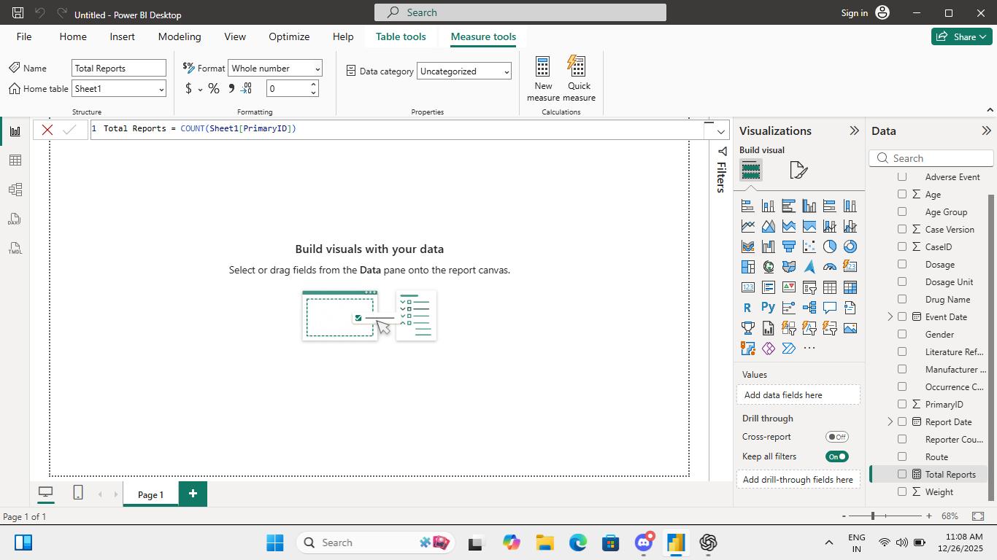
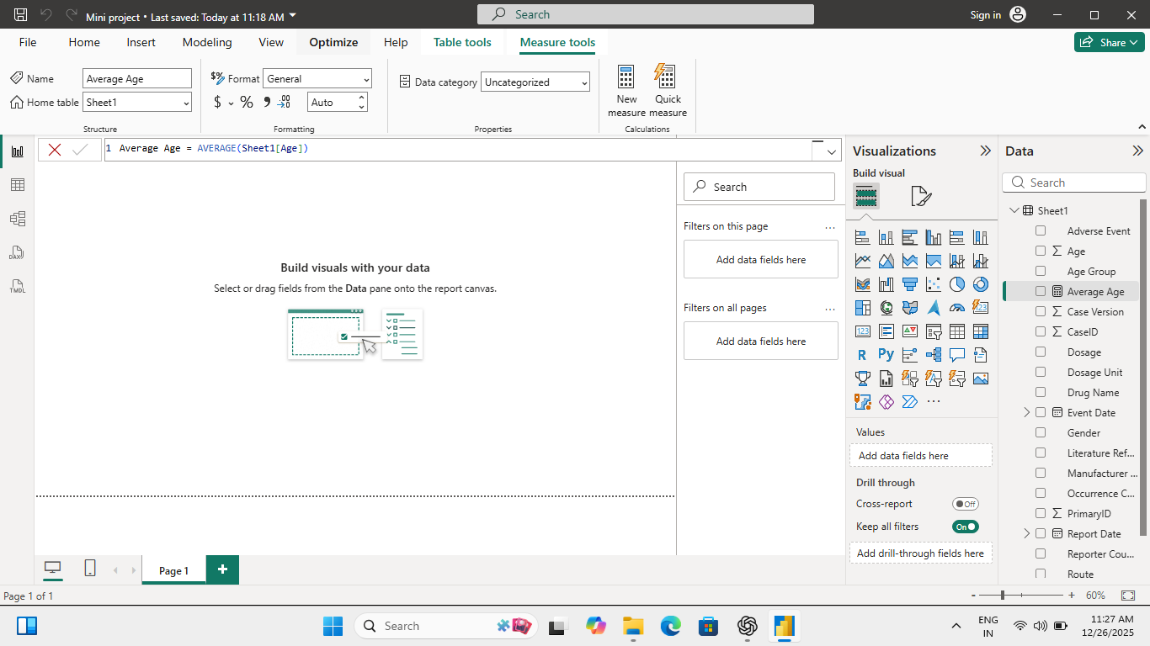

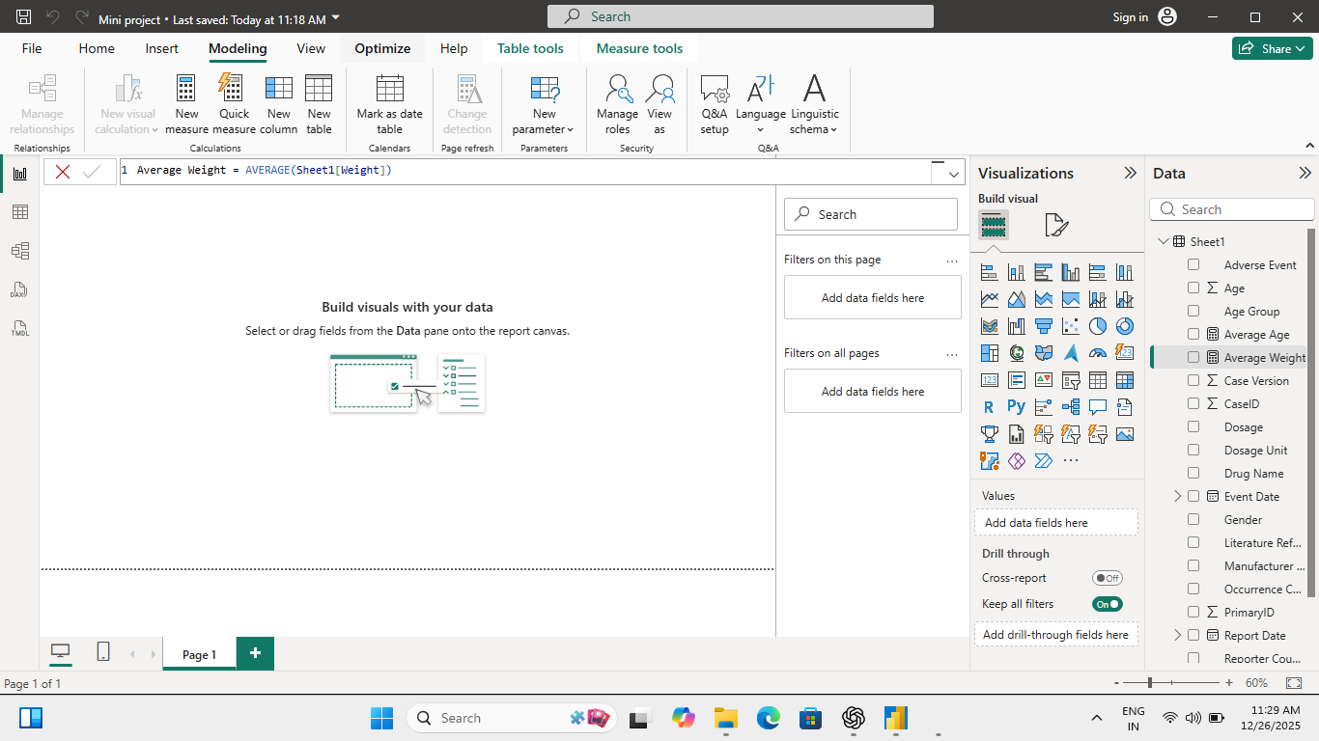

Analysis and Visualizations (Power BI)

Overview of Analytical Approach
After completing data preprocessing and data modeling, the cleaned dataset was analyzed using Power BI to identify meaningful patterns in adverse drug event reporting. The analysis focused on answering key pharmacovigilance questions related to drug safety, patient demographics, adverse event frequency, routes of administration, and reporting trends over time.
Interactive visualizations were designed to allow dynamic exploration of the data using filters and slicers. Each visualization was created with a specific analytical objective to ensure clarity, interpretability, and relevance.

Key Performance Indicators (KPI Cards)
Visual Used: KPI Cards
The dashboard includes KPI cards displaying:
- Total number of adverse event reports
- Average age of affected patients
- Average weight of affected patients
Purpose:
KPI cards provide a high-level summary of the dataset and allow users to quickly understand the overall scale and demographic characteristics of reported cases.
Why this visualization was chosen:
- Enables instant insight into key metrics
- Responds dynamically to filters and slicers
- Serves as a reference point for all other analyses
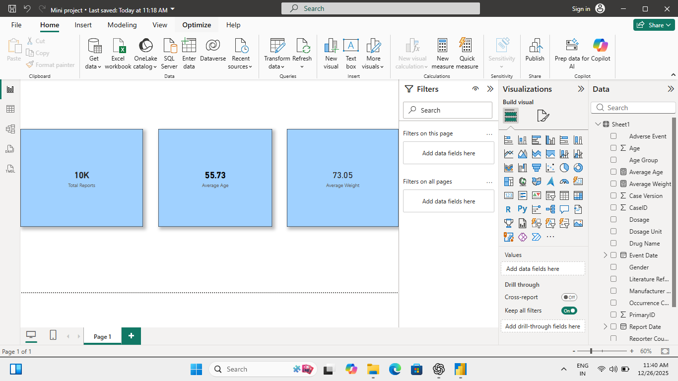

8.3 Top 10 Primary Suspect Drugs
Visual Used: Bar Chart
This visualization displays the top 10 drugs most frequently reported as primary suspects in adverse event cases.
Analysis Performed:
- Reports were aggregated by primary suspect drug
- “Not Reported” values were excluded at the visual level
- Top-N filtering was applied to highlight the most relevant drugs
Purpose:
To identify drugs that are most commonly associated with adverse event reports.
Insight Provided:
This visualization helps prioritize drugs that may require closer pharmacovigilance monitoring or further investigation.
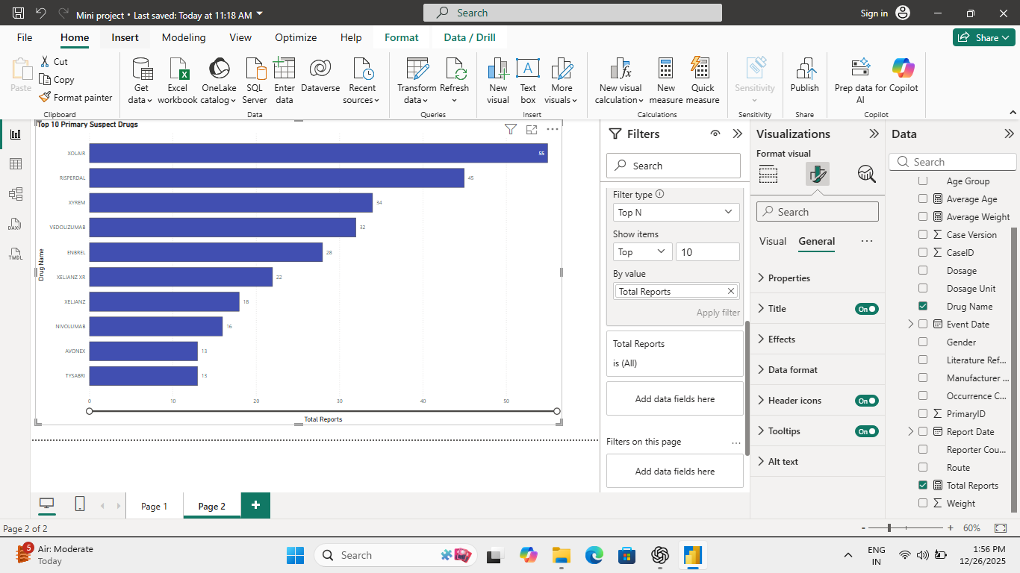

8.4 Top 10 Reported Adverse Events
Visual Used: Bar Chart
This chart shows the most frequently reported adverse events based on Preferred Term (PT) classification.
Analysis Performed:
- Adverse events were grouped and counted
- Filters were applied to remove non-informative values
- Sorted in descending order for better interpretation
Purpose:
To understand the most common types of adverse reactions reported across all drugs.
Insight Provided:
The visualization highlights recurring safety concerns and helps identify patterns in reported adverse reactions.
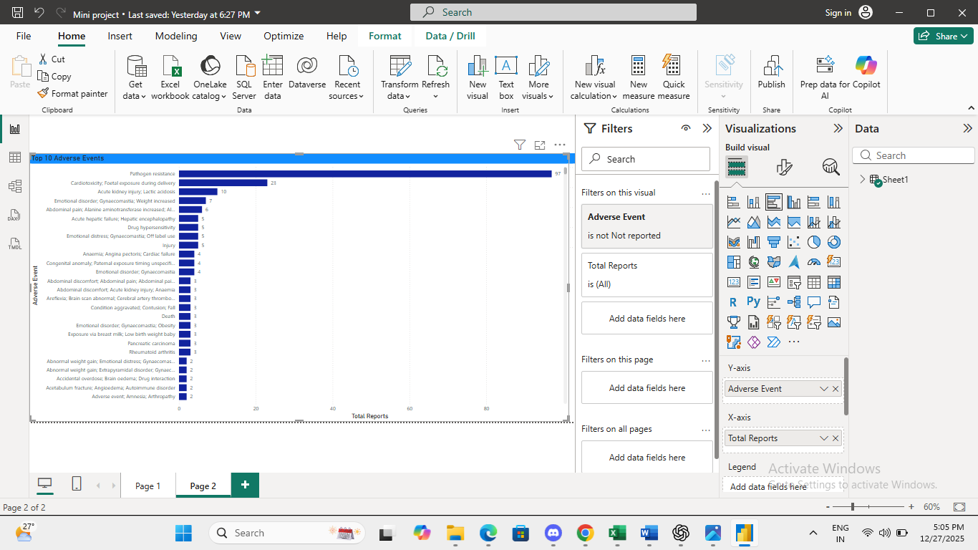

8.5 Reports by Age Group
Visual Used: Column Chart
This visualization displays the distribution of adverse event reports across different age groups such as Infant, Child, Adult, and Elderly.
Analysis Performed:
- Age group abbreviations were expanded during preprocessing
- Reports were aggregated by age group
Purpose:
To analyze which demographic groups are most affected by adverse drug events.
Insight Provided:
The chart shows that certain age groups, particularly adults and elderly populations, account for a higher proportion of reported cases.
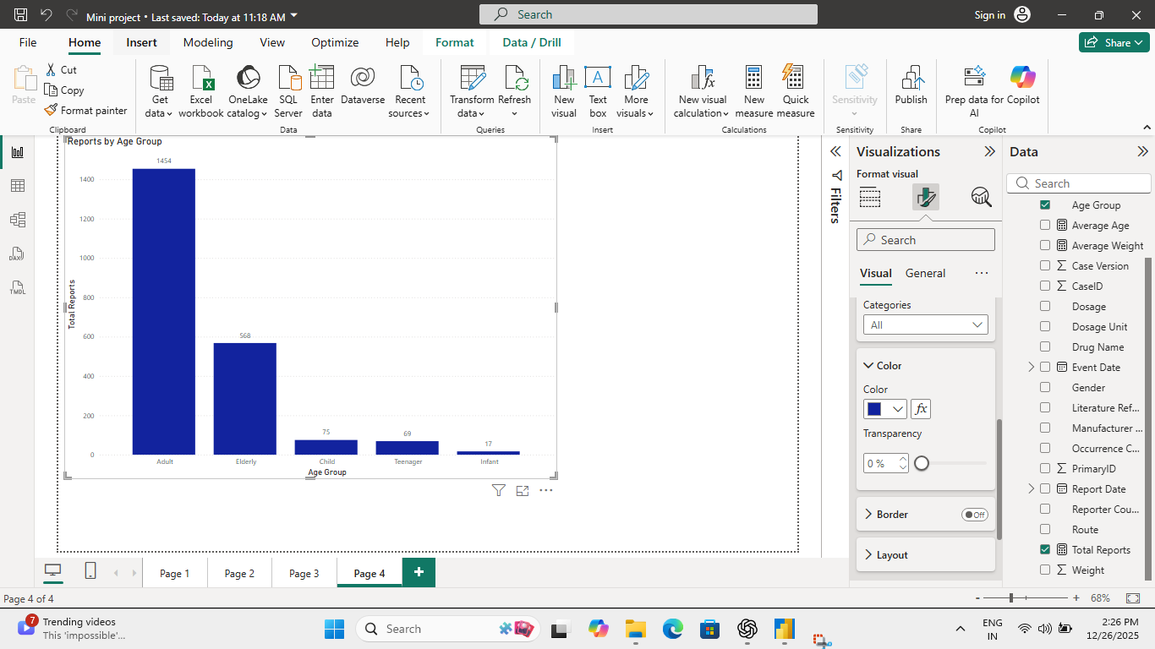

8.6 Route of Drug Administration
Visual Used: Donut Chart
This visualization represents the distribution of adverse event reports by route of administration (e.g., Oral, Intravenous).
Analysis Performed:
- Reports were grouped by route
- Less frequent routes were visually de-emphasized
Purpose:
To understand how drug administration routes relate to adverse event reporting.
Insight Provided:
Oral and intravenous routes dominate reporting, indicating common modes of drug usage associated with adverse events.
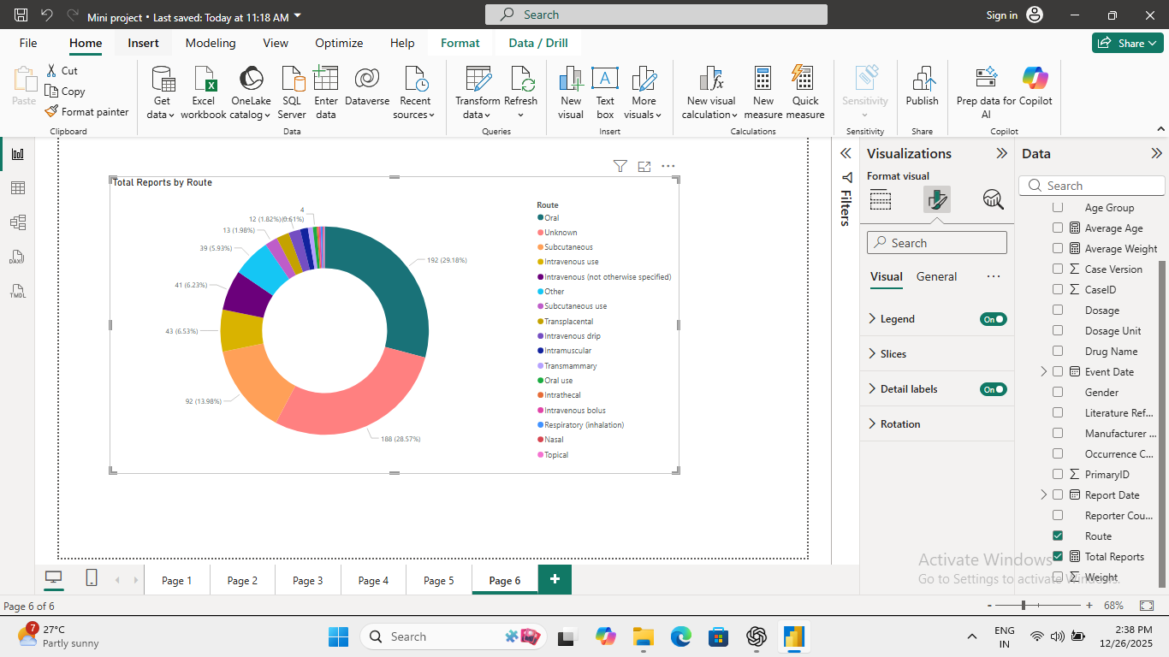

8.7 Adverse Event Reports Over Time
Visual Used: Line Chart
This visualization shows trends in adverse event reporting over time based on event or report dates.
Analysis Performed:
- Date-time values were standardized during preprocessing
- Missing dates were excluded from trend analysis
- Reports were aggregated by time period
Purpose:
To identify temporal trends and changes in reporting behavior.
Insight Provided:
An upward trend in reporting is observed in recent periods, reflecting increased awareness and improved reporting practices.
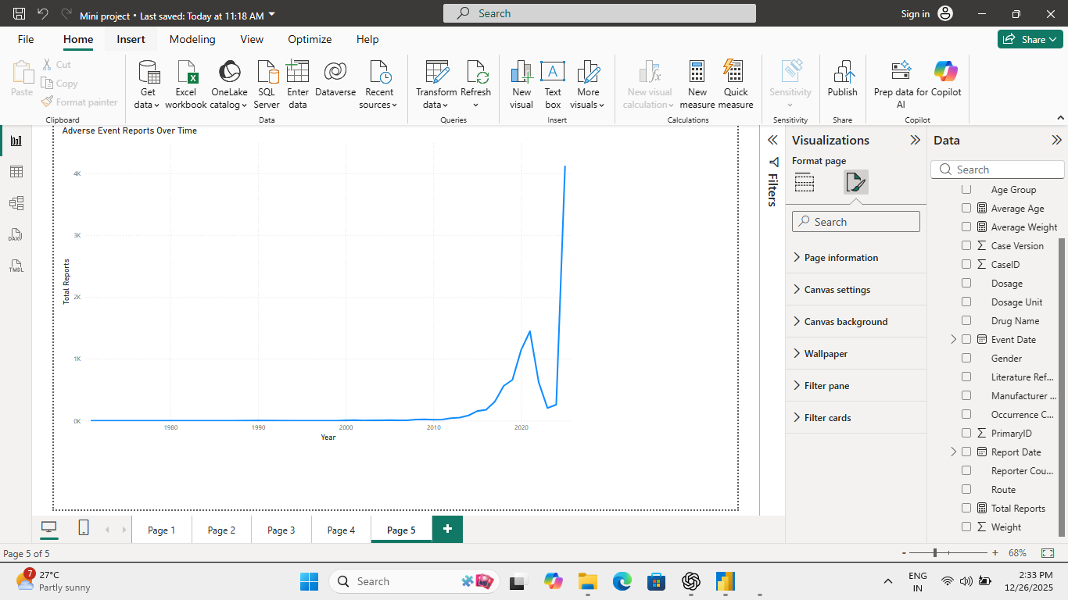

8.8 Use of Filters and Slicers
Slicers Used:
- Event Date
- Age Group
- Route of Administration
Purpose:
Filters and slicers allow users to dynamically interact with the dashboard and focus on specific subsets of data without altering the underlying dataset.
Benefit:
- Enhances exploratory analysis
- Improves user engagement
- Supports flexible, scenario-based insights

Overall Analytical Outcome
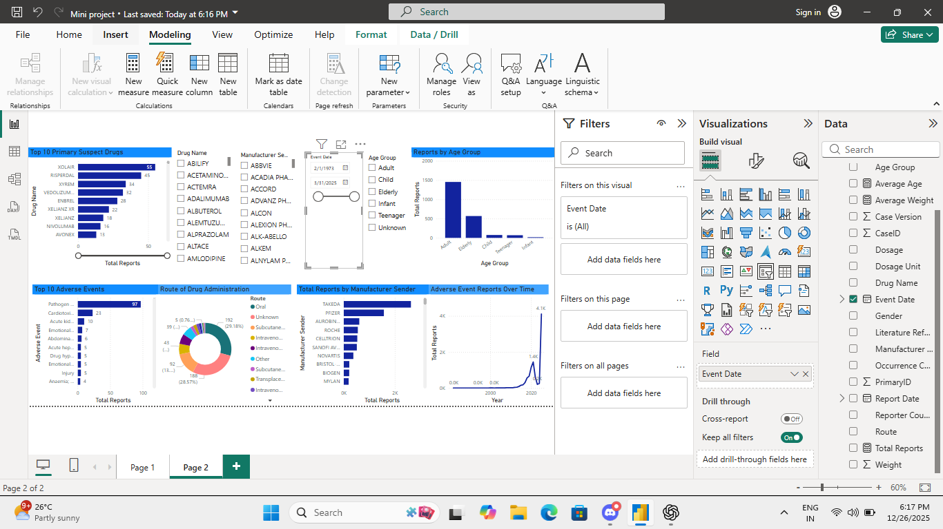

Insights & Conclusions

Key Findings
The analysis of the FAERS adverse event dataset reveals that XOLAIR is the most frequently reported primary suspect drug, followed by RISPERDAL and XYREM. Manufacturer-wise, TAKEDA has submitted the highest number of adverse event reports, indicating either a larger market presence or stronger pharmacovigilance reporting practices.
The adult and elderly age groups contribute to the majority of reported cases, suggesting that adverse events are more commonly associated with long-term medication usage and chronic disease management. The oral route of administration dominates adverse event reporting, followed by subcutaneous and intravenous routes.
A sharp increase in adverse event reporting over recent years, particularly after 2018, highlights improved regulatory compliance, increased patient awareness, and enhanced post-marketing surveillance activities.

Analysis Insights

1. Descriptive Analysis (What happened?)
- XOLAIR recorded the highest number of adverse event reports, making it the most prominent drug in the dataset.
- RISPERDAL and XYREM also show significant reporting frequency, indicating close monitoring or higher patient exposure.
- TAKEDA is the leading manufacturer sender, followed by PFIZER, ROCHE, and AURINIA.
- Adults represent the largest affected population group, followed by the elderly, while children and infants show comparatively fewer reports.
- The oral route accounts for the majority of drug administrations linked to adverse events.
- Adverse event reporting shows minimal activity in earlier years and a steep rise in recent years.

2. Diagnostic Analysis (Why did it happen?)
- Drugs like XOLAIR and RISPERDAL are widely prescribed for chronic and immune-related conditions, increasing long-term exposure and reporting likelihood.
- Higher reports from TAKEDA may be due to a robust pharmacovigilance system and proactive reporting rather than poor drug safety alone.
- Adults and elderly patients often take multiple medications (polypharmacy), increasing the risk of adverse reactions.
- Oral administration is the most common drug delivery method, explaining its higher association with reported events.
- The spike in recent years correlates with stricter regulatory requirements and increased awareness of adverse event reporting systems.

3. Predictive Analysis (What is likely to happen?)
- Adverse event reporting is expected to continue increasing as regulatory frameworks and reporting awareness strengthen.
- Drugs such as XOLAIR and RISPERDAL will likely remain under close regulatory scrutiny due to consistent reporting trends.
- Manufacturers with high reporting volumes, such as TAKEDA, may face more frequent safety reviews and post-marketing studies.
- Elderly patient groups may show increased adverse event trends due to aging populations and rising chronic disease prevalence.

4. Prescriptive Analysis (What should be done?)
- Regulatory bodies should prioritize continuous monitoring of high-risk drugs like XOLAIR and RISPERDAL.
- Manufacturers should enhance risk management plans and provide clearer safety communication for long-term therapies.
- Healthcare providers should exercise greater caution when prescribing to elderly patients, particularly in cases of polypharmacy.
- Improved data completeness (reducing “Not Reported” entries) should be enforced to strengthen future pharmacovigilance analysis.
- Advanced analytics and early-warning systems should be implemented to detect emerging safety signals proactively.

Overall Conclusion
This mini project demonstrates how Excel-based data preprocessing and Power BI analytics can transform raw FAERS data into actionable pharmacovigilance insights. By identifying high-risk drugs, manufacturers, patient demographics, and reporting trends, the analysis supports informed decision-making for regulators, healthcare providers, and pharmaceutical companies.

Bottom of Form

